NUTRITION WHOLE VS. PROCESSED FOODS

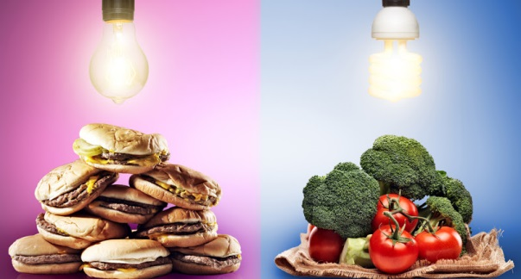
Discover how much is missing in your diet by understanding what makes whole food different from processed food.

By Katja Breceljnik
13 August, 2015 at 07:30AM

The term ‘food’ has changed dramatically in the last 100 years! Since the dawn of time people have survived eating what we call today organic, whole foods. Sadly, organic whole foods are considered a luxury and almost a specialty item in this day and age, indicating just how far away from nature we’ve come. As food was taken from the hands of the farmers to processing plants, we began a new era of food products, which our ancestors would not recognize.
The hidden ingredients that make food more appealing to our tastebuds are added to a large percentage of all heavily processed foods. The 3 main ingredients, fat, sugar, and salt, are known to excite our taste buds and make us want more. They perpetuate an addictive cycle many people struggle with. Neuroscientists link overeating to food addiction due to high amounts of refined sugar and fat in diets. Whole foods on the other hand, with their amino acids, vitamins, minerals, glucose and fatty acids packed with fiber along with many other nutrients, do not perpetuate the same addictive problem.

Whole Foods
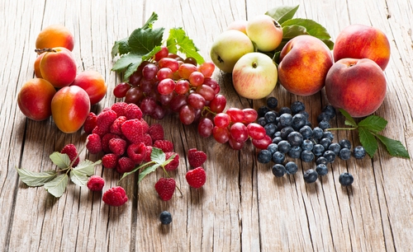
Whole foods represent foods that retain their natural composition as well as contain no artificial additives or preservatives and have gone through little or no processing (i.e. cooking, grinding, or blending). Whole foods contain vitamins, minerals, water, fatty acids, amino acids, carbohydrates, fiber and much more.
Each whole food, be it a nut or apple, quinoa or banana, contains more nutrients than we are currently familiar with. In other words, we do not yet have a complete list of all the nutrients inside whole foods that are essential to human nutrition.
While we do not yet fully understand how these nutrients interrelate with each other or how they are distributed inside our bodies, however we are beginning to understand that they are codependent in their function. Our bodies have been in tight relationship with whole foods for as long as we have been on this planet. We require the full spectrum nutrition for optimal functioning, which only whole foods can provide.

Processed Foods
Processed foods have their natural composition altered in some way. This is a very wide field, which I will touch upon only on the surface. First of all, not all processing is unhealthy, of course. Light processing like cooking, freezing, blending, soaking, fermenting or drying can be quite healthy if done using whole foods and avoiding heavily processed ingredients.
Some dried herbs (e.g. basil, chili, cilantro, dill, garlic, ginger, lemongrass, oregano, and parsley) are high in antioxidants and beneficial to our health. Fermented foods have shown to be highly beneficial for our gut as well as brain health and are being used in nutritional psychiatry. Sprouting grains increases their digestibility, improves amino acid profile, B vitamins and sugar composition.
Foods with heavier processing or added ultraprocessed elements is usually what we have in mind when we speak about processed foods. Heavily processed foods can be extracted from whole foods (e.g. oils, sugars, MSG, food dyes, extracted proteins, other food stabilizing additives, etc) or artificial sources (e.g. artificial food dyes are a byproducts of burning coal tar). Most food processing also involves natural or artificial agents (salt, sugar, sodium or potassium benzoate, parabens, etc.) to preserve freshness and prevent spoiling.
While eating whole foods will give you unspoiled fatty acids, extracted lipids can become very unstable and oxidize quickly during processing, which produces dangerous free radicals and degrades proteins and vitamins. Solid fats and added sugars are known to excite our taste buds, however they provide nothing but empty calories (e.g. pizzas, conventional pastry and breads, cakes, candy, and other artificial and sugary drinks). When I hear “empty calorie,” I ask myself what they are empty of? They are empty of a large number of beneficial nutrients we find in natural, whole foods.

Whole foods is greater than the sum of its parts
We live in a society where many no longer recognize what is real whole food and what is an artificial product made of its parts. We reduced food to one nutrient by thinking only about proteins, sugar, or fats, but we ignore the whole spectrum of health sustaining nutrients we depend on. We overeat on convenient foods, not realizing that we have overeaten on fats, sugars or salt, which are freely added almost everywhere and created nutritional imbalance along the way.
We forget that individual nutrients are not our enemy, but the form in which they come from and thus, their excess, is. These heavily processed foods and drinks promote weight gain and obesity throughout the world and with that, increases our risk for diabetes, cardiovascular disease, and certain types of cancers.
Living in a modern world we can’t always avoid some heavily processed foods on our plates, however having whole foods as a staple is the surest way to regain not only our waistline, but also our health. A healthy connection with food, where an apple is no longer defined by one of its many nutrients, but by its whole, multi- nutritional package, can have a balanced effect on our body’s overall wellbeing.
Katja Breceljnik is a Clinical Nutritionist who runs the blog More Than An Apple. She graduated from the California College of Natural Medicine and has received a certificate in NeuroEndocrine Regulation & Anti-Aging. She is a passionate advocate for healthy living in a dirty city. She has helped many people with both reversing their symptoms and gaining understanding of the connection between their symptoms and the cause.
Main Photo Credit: Joshua Resnick/ shutterstock.com; Second Photo Credit: Iryna Denysova/ shutterstock.com; Third Photo Credit: Joe Gough/ shutterstock.com; Fourth Photo Credit: Monkey Business Images/ shutterstock.com

